Domestic commercial vessel log and records

Gypsea 463754

Contents
OWNER’S / MASTER’S RESPONSIBILITY AND AUTHORITY STATEMENT 2
Pre-operating check list 7
Master induction checklist 15
Training induction record 23
INCIDENT REPORTING FORMS 23
INCIDENT ALERT AMSA Form 18 24
Incident Report AMSA Form 19 28
MAINTENANCE RECORD 40
Skippers cards 50
Australian 406 MHz Distress Beacon 52
Engine plate 54
Last Service history 55

OWNER’S / MASTER’S RESPONSIBILITY AND AUTHORITY STATEMENT

Responsibility and authority statement

I ___________________________the Owner / Master is responsible for the safe operation of the vessel and the safety of the personnel onboard. The Owner / Master has the overriding authority and responsibility to make decisions with regard to the vessel’s safety and environmental protection.

The Owner / Master is responsible for:
- Holding and maintaining relevant AMSA certification;
- Identification of appropriate crew members;
- Induction and management of crew members;
- Monitoring vessel safety – taking into consideration the vessel’s capabilities, sea conditions and weather conditions;
- The purchase of equipment and supplies as required;
- Check and maintain lifesaving, medical, communication and firefighting equipment;
- Record keeping including logbook maintenance, vessel & equipment maintenance, non-conformances, hazards/risk assessment, incident reports and other relevant requirements;
- The registration of the vessel.

Date _____________________________________________________________
Signature ____________________________________________________
Certification __________________________________________________
AMSA ID ______________________________________________________

Responsibility and authority statement

I ___________________________the Owner / Master is responsible for the safe operation of the vessel and the safety of the personnel onboard. The Owner / Master has the overriding authority and responsibility to make decisions with regard to the vessel’s safety and environmental protection.

The Owner / Master is responsible for:
- Holding and maintaining relevant AMSA certification;
- Identification of appropriate crew members;
- Induction and management of crew members;
- Monitoring vessel safety – taking into consideration the vessel’s capabilities, sea conditions and weather conditions;
- The purchase of equipment and supplies as required;
- Check and maintain lifesaving, medical, communication and firefighting equipment;
- Record keeping including logbook maintenance, vessel & equipment maintenance, non-conformances, hazards/risk assessment, incident reports and other relevant requirements;
- The registration of the vessel.

Date _____________________________________________________________
Signature ____________________________________________________
Certification __________________________________________________
AMSA ID ______________________________________________________
Responsibility and authority statement

I ___________________________the Owner / Master is responsible for the safe operation of the vessel and the safety of the personnel onboard. The Owner / Master has the overriding authority and responsibility to make decisions with regard to the vessel’s safety and environmental protection.

The Owner / Master is responsible for:
- Holding and maintaining relevant AMSA certification;
- Identification of appropriate crew members;
- Induction and management of crew members;
- Monitoring vessel safety – taking into consideration the vessel’s capabilities, sea conditions and weather conditions;
- The purchase of equipment and supplies as required;
- Check and maintain lifesaving, medical, communication and firefighting equipment;
- Record keeping including logbook maintenance, vessel & equipment maintenance, non-conformances, hazards/risk assessment, incident reports and other relevant requirements;
- The registration of the vessel.

Date _____________________________________________________________
Signature ____________________________________________________
Certification __________________________________________________
AMSA ID ______________________________________________________

Responsibility and authority statement

I ___________________________the Owner / Master is responsible for the safe operation of the vessel and the safety of the personnel onboard. The Owner / Master has the overriding authority and responsibility to make decisions with regard to the vessel’s safety and environmental protection.

The Owner / Master is responsible for:
- Holding and maintaining relevant AMSA certification;
- Identification of appropriate crew members;
- Induction and management of crew members;
- Monitoring vessel safety – taking into consideration the vessel’s capabilities, sea conditions and weather conditions;
- The purchase of equipment and supplies as required;
- Check and maintain lifesaving, medical, communication and firefighting equipment;
- Record keeping including logbook maintenance, vessel & equipment maintenance, non-conformances, hazards/risk assessment, incident reports and other relevant requirements;
- The registration of the vessel.

Date _____________________________________________________________
Signature ____________________________________________________
Certification __________________________________________________
AMSA ID ______________________________________________________

Pre-operating check list

PRE-OPERATING / DEPARTURE CHECKLIST
Engines | Yes | No | N/A
Owner / Master / Engineer shall check fuel levels. Check for leaks including fuel.
Pre-departure | Yes | No | N/A
Sufficient stores and drinking water onboard for trip
Spare engine oil
Spare oil and fuel filters |  |  | Na
Master to check that all crew are fit for trip
All safety devices and equipment are located in designated spot
Radios and phones and/or satellite phone are in good working order
While at sea, regular check of radio and equipment including power source. Failures to be reported to Master and documented in logbook
Upon Masters instruction, crew shall release the ropes for departure |  |  | Na
Batteries | Yes | No | N/A
Master / Engineer to ensure all batteries are in good working order
Recreational Use | Yes | No | N/A
If the vessel is to be used for recreational purposes under Exemption 4, the Master will ensure that it’s not used for commercial, government or research activity. The Master will ensure that the vessel is in compliance with its maximum load, passenger restrictions and local recreational vessel requirements – except those requiring the vessel be registered as a recreational vessel or to meet Australian Builder’s Plate Requirement
The vessel’s safety management system is able to deal with the risks of operating the vessel for recreational use
Powered equipment, lifting equipment or other machinery that could pose a danger to passengers are secured and/or isolated from passengers
Any operation of the vessel for recreational purposes shall be recorded in the vessel’s logbook
Refueling | Yes | No | N/A
Vessel is securely moored |  |  | na
Engines / auxiliary / radios / radar / electrical are shutdown |  |  | na
Deck fittings are prepared |  |  | na
Spill material / extinguisher readied
Fuel tank breathers are clear
Correct PPE is worn
Nozzle grounded during filling |  |  | na
Monitor filling
Timer on during fill to avoid overfilling |  |  | na
Spill clean up
Tank caps and deck fitting have been resecured
Bilges and tanks checked for leaks
Anchoring | Yes | No | N/A
Briefing to be provided to deckhand(s) prior to anchoring operations
Anchor winch to be operated by Master / Engineer / nominated crew |  |  | na
As per Master, deckhand shall prepare the anchor for release, remove devils’ claw and await further instruction
As per Master, deckhand shall release gypsy brake and let chain/anchor release to required fathoms of chain
Re-tighten gypsy chain |  |  | na
Re-apply devils’ claw to take load from windlass |  |  | na
Master to maneuver vessel astern as appropriate
Master to monitor vessel holding position
Master to activate vessel radar and GPS anchor watch alarms |  |  | na
Steaming | Yes | No | N/A
Master to organize crew roster for steaming
Turn on watch guard |  |  | na
Set C plot alarm |  |  | na
Maintain visuals at all times
Turn radar on |  |  | na
Set personal phone alarms as backup |  |  | na
2 people on watch within 15 miles of return to port
Master and another crew member on watch for last 10 miles of return to port
If fatigue has set in, take boat out of gear and turn on appropriate navigation lights and set radar alarm in case a vessel comes inside the ring and have a rest/sleep

Master ___________________________________
Date _____________________________________

PRE-OPERATING / DEPARTURE CHECKLIST
Engines | Yes | No | N/A
Owner / Master / Engineer shall check fuel levels. Check for leaks including fuel.
Pre-departure | Yes | No | N/A
Sufficient stores and drinking water onboard for trip
Spare engine oil
Spare oil and fuel filters |  |  | Na
Master to check that all crew are fit for trip
All safety devices and equipment are located in designated spot
Radios and phones and/or satellite phone are in good working order
While at sea, regular check of radio and equipment including power source. Failures to be reported to Master and documented in logbook
Upon Masters instruction, crew shall release the ropes for departure |  |  | Na
Batteries | Yes | No | N/A
Master / Engineer to ensure all batteries are in good working order
Recreational Use | Yes | No | N/A
If the vessel is to be used for recreational purposes under Exemption 4, the Master will ensure that it’s not used for commercial, government or research activity. The Master will ensure that the vessel is in compliance with its maximum load, passenger restrictions and local recreational vessel requirements – except those requiring the vessel be registered as a recreational vessel or to meet Australian Builder’s Plate Requirement
The vessel’s safety management system is able to deal with the risks of operating the vessel for recreational use
Powered equipment, lifting equipment or other machinery that could pose a danger to passengers are secured and/or isolated from passengers
Any operation of the vessel for recreational purposes shall be recorded in the vessel’s logbook
Refueling | Yes | No | N/A
Vessel is securely moored |  |  | na
Engines / auxiliary / radios / radar / electrical are shutdown |  |  | na
Deck fittings are prepared |  |  | na
Spill material / extinguisher readied
Fuel tank breathers are clear
Correct PPE is worn
Nozzle grounded during filling |  |  | na
Monitor filling
Timer on during fill to avoid overfilling |  |  | na
Spill clean up
Tank caps and deck fitting have been resecured
Bilges and tanks checked for leaks
Anchoring | Yes | No | N/A
Briefing to be provided to deckhand(s) prior to anchoring operations
Anchor winch to be operated by Master / Engineer / nominated crew |  |  | na
As per Master, deckhand shall prepare the anchor for release, remove devils’ claw and await further instruction
As per Master, deckhand shall release gypsy brake and let chain/anchor release to required fathoms of chain
Re-tighten gypsy chain |  |  | na
Re-apply devils’ claw to take load from windlass |  |  | na
Master to maneuver vessel astern as appropriate
Master to monitor vessel holding position
Master to activate vessel radar and GPS anchor watch alarms |  |  | na
Steaming | Yes | No | N/A
Master to organize crew roster for steaming
Turn on watch guard |  |  | na
Set C plot alarm |  |  | na
Maintain visuals at all times
Turn radar on |  |  | na
Set personal phone alarms as backup |  |  | na
2 people on watch within 15 miles of return to port
Master and another crew member on watch for last 10 miles of return to port
If fatigue has set in, take boat out of gear and turn on appropriate navigation lights and set radar alarm in case a vessel comes inside the ring and have a rest/sleep

Master ___________________________________
Date ___________________________________

PRE-OPERATING / DEPARTURE CHECKLIST
Engines | Yes | No | N/A
Owner / Master / Engineer shall check fuel levels. Check for leaks including fuel.
Pre-departure | Yes | No | N/A
Sufficient stores and drinking water onboard for trip
Spare engine oil
Spare oil and fuel filters |  |  | Na
Master to check that all crew are fit for trip
All safety devices and equipment are located in designated spot
Radios and phones and/or satellite phone are in good working order
While at sea, regular check of radio and equipment including power source. Failures to be reported to Master and documented in logbook
Upon Masters instruction, crew shall release the ropes for departure |  |  | Na
Batteries | Yes | No | N/A
Master / Engineer to ensure all batteries are in good working order
Recreational Use | Yes | No | N/A
If the vessel is to be used for recreational purposes under Exemption 4, the Master will ensure that it’s not used for commercial, government or research activity. The Master will ensure that the vessel is in compliance with its maximum load, passenger restrictions and local recreational vessel requirements – except those requiring the vessel be registered as a recreational vessel or to meet Australian Builder’s Plate Requirement
The vessel’s safety management system is able to deal with the risks of operating the vessel for recreational use
Powered equipment, lifting equipment or other machinery that could pose a danger to passengers are secured and/or isolated from passengers
Any operation of the vessel for recreational purposes shall be recorded in the vessel’s logbook
Refueling | Yes | No | N/A
Vessel is securely moored |  |  | na
Engines / auxiliary / radios / radar / electrical are shutdown |  |  | na
Deck fittings are prepared |  |  | na
Spill material / extinguisher readied
Fuel tank breathers are clear
Correct PPE is worn
Nozzle grounded during filling |  |  | na
Monitor filling
Timer on during fill to avoid overfilling |  |  | na
Spill clean up
Tank caps and deck fitting have been resecured
Bilges and tanks checked for leaks
Anchoring | Yes | No | N/A
Briefing to be provided to deckhand(s) prior to anchoring operations
Anchor winch to be operated by Master / Engineer / nominated crew |  |  | na
As per Master, deckhand shall prepare the anchor for release, remove devils’ claw and await further instruction
As per Master, deckhand shall release gypsy brake and let chain/anchor release to required fathoms of chain
Re-tighten gypsy chain |  |  | na
Re-apply devils’ claw to take load from windlass |  |  | na
Master to maneuver vessel astern as appropriate
Master to monitor vessel holding position
Master to activate vessel radar and GPS anchor watch alarms |  |  | na
Steaming | Yes | No | N/A
Master to organize crew roster for steaming
Turn on watch guard |  |  | na
Set C plot alarm |  |  | na
Maintain visuals at all times
Turn radar on |  |  | na
Set personal phone alarms as backup |  |  | na
2 people on watch within 15 miles of return to port
Master and another crew member on watch for last 10 miles of return to port
If fatigue has set in, take boat out of gear and turn on appropriate navigation lights and set radar alarm in case a vessel comes inside the ring and have a rest/sleep

Master ___________________________________
Date _____________________________________

PRE-OPERATING / DEPARTURE CHECKLIST
Engines | Yes | No | N/A
Owner / Master / Engineer shall check fuel levels. Check for leaks including fuel.
Pre-departure | Yes | No | N/A
Sufficient stores and drinking water onboard for trip
Spare engine oil
Spare oil and fuel filters |  |  | Na
Master to check that all crew are fit for trip
All safety devices and equipment are located in designated spot
Radios and phones and/or satellite phone are in good working order
While at sea, regular check of radio and equipment including power source. Failures to be reported to Master and documented in logbook
Upon Masters instruction, crew shall release the ropes for departure |  |  | Na
Batteries | Yes | No | N/A
Master / Engineer to ensure all batteries are in good working order
Recreational Use | Yes | No | N/A
If the vessel is to be used for recreational purposes under Exemption 4, the Master will ensure that it’s not used for commercial, government or research activity. The Master will ensure that the vessel is in compliance with its maximum load, passenger restrictions and local recreational vessel requirements – except those requiring the vessel be registered as a recreational vessel or to meet Australian Builder’s Plate Requirement
The vessel’s safety management system is able to deal with the risks of operating the vessel for recreational use
Powered equipment, lifting equipment or other machinery that could pose a danger to passengers are secured and/or isolated from passengers
Any operation of the vessel for recreational purposes shall be recorded in the vessel’s logbook
Refueling | Yes | No | N/A
Vessel is securely moored |  |  | na
Engines / auxiliary / radios / radar / electrical are shutdown |  |  | na
Deck fittings are prepared |  |  | na
Spill material / extinguisher readied
Fuel tank breathers are clear
Correct PPE is worn
Nozzle grounded during filling |  |  | na
Monitor filling
Timer on during fill to avoid overfilling |  |  | na
Spill clean up
Tank caps and deck fitting have been resecured
Bilges and tanks checked for leaks
Anchoring | Yes | No | N/A
Briefing to be provided to deckhand(s) prior to anchoring operations
Anchor winch to be operated by Master / Engineer / nominated crew |  |  | na
As per Master, deckhand shall prepare the anchor for release, remove devils’ claw and await further instruction
As per Master, deckhand shall release gypsy brake and let chain/anchor release to required fathoms of chain
Re-tighten gypsy chain |  |  | na
Re-apply devils’ claw to take load from windlass |  |  | na
Master to maneuver vessel astern as appropriate
Master to monitor vessel holding position
Master to activate vessel radar and GPS anchor watch alarms |  |  | na
Steaming | Yes | No | N/A
Master to organize crew roster for steaming
Turn on watch guard |  |  | na
Set C plot alarm |  |  | na
Maintain visuals at all times
Turn radar on |  |  | na
Set personal phone alarms as backup |  |  | na
2 people on watch within 15 miles of return to port
Master and another crew member on watch for last 10 miles of return to port
If fatigue has set in, take boat out of gear and turn on appropriate navigation lights and set radar alarm in case a vessel comes inside the ring and have a rest/sleep

Master ___________________________________
Date ___________________________________

Master induction checklist

VESSEL SAFETY INDUCTION CHECKLIST
Safety Equipment – Location & Use | Complete  ( or x as required)
EPIRB | ☐
Personal Floatation Device / Lifejacket | ☐
Life Ring | ☐
Flares | ☐
Fire Extinguisher (specific types & uses) | ☐
Life raft (if applicable) NA | ☐
First Aid Kit | ☐
Emergency Torch | ☐
Seasickness (precautions / remedies) NA | ☐
Marine Radio (or other communication device) | ☐
Emergency Procedures | Complete  ( or x as required )
Fire | ☐
Person Overboard | ☐
Personal Injury / Medical Emergency | ☐
Master Incapacitated | ☐
Vessel Collision | ☐
Vessel Grounding | ☐
Vessel Flooding | ☐
Loss of Steering | ☐
Adverse Weather Conditions | ☐
Other:☐ | ☐
Operational Procedures | Complete  ( or x as required )
Safety Management System | ☐
Pre-operating Checks & Start Up | ☐
Stop / Start the Vessel (Engine) | ☐
No Go Areas NA | ☐
Secure Mooring of Vessel | ☐
Hook up/Snagging | ☐
Anchoring | ☐
Smoking & Mobile Phone Usage | ☐
Refueling | ☐
Spill Clean Up | ☐
Securing Caps/Tanks (refueling) | ☐
Removal of Portable Tanks from Vessel | ☐

Master_______________________

Date _______________________

VESSEL SAFETY INDUCTION CHECKLIST
Safety Equipment – Location & Use | Complete  ( or x as required)
EPIRB | ☐
Personal Floatation Device / Lifejacket | ☐
Life Ring | ☐
Flares | ☐
Fire Extinguisher (specific types & uses) | ☐
Life raft (if applicable) NA | ☐
First Aid Kit | ☐
Emergency Torch | ☐
Seasickness (precautions / remedies) NA | ☐
Marine Radio (or other communication device) | ☐
Emergency Procedures | Complete  ( or x as required )
Fire | ☐
Person Overboard | ☐
Personal Injury / Medical Emergency | ☐
Master Incapacitated | ☐
Vessel Collision | ☐
Vessel Grounding | ☐
Vessel Flooding | ☐
Loss of Steering | ☐
Adverse Weather Conditions | ☐
Other:☐ | ☐
Operational Procedures | Complete  ( or x as required )
Safety Management System | ☐
Pre-operating Checks & Start Up | ☐
Stop / Start the Vessel (Engine) | ☐
No Go Areas NA | ☐
Secure Mooring of Vessel | ☐
Hook up/Snagging | ☐
Anchoring | ☐
Smoking & Mobile Phone Usage | ☐
Refueling | ☐
Spill Clean Up | ☐
Securing Caps/Tanks (refueling) | ☐
Removal of Portable Tanks from Vessel | ☐

Master_______________________

Date _______________________

VESSEL SAFETY INDUCTION CHECKLIST
Safety Equipment – Location & Use | Complete  ( or x as required)
EPIRB | ☐
Personal Floatation Device / Lifejacket | ☐
Life Ring | ☐
Flares | ☐
Fire Extinguisher (specific types & uses) | ☐
Life raft (if applicable) NA | ☐
First Aid Kit | ☐
Emergency Torch | ☐
Seasickness (precautions / remedies) NA | ☐
Marine Radio (or other communication device) | ☐
Emergency Procedures | Complete  ( or x as required )
Fire | ☐
Person Overboard | ☐
Personal Injury / Medical Emergency | ☐
Master Incapacitated | ☐
Vessel Collision | ☐
Vessel Grounding | ☐
Vessel Flooding | ☐
Loss of Steering | ☐
Adverse Weather Conditions | ☐
Other:☐ | ☐
Operational Procedures | Complete  ( or x as required )
Safety Management System | ☐
Pre-operating Checks & Start Up | ☐
Stop / Start the Vessel (Engine) | ☐
No Go Areas NA | ☐
Secure Mooring of Vessel | ☐
Hook up/Snagging | ☐
Anchoring | ☐
Smoking & Mobile Phone Usage | ☐
Refueling | ☐
Spill Clean Up | ☐
Securing Caps/Tanks (refueling) | ☐
Removal of Portable Tanks from Vessel | ☐

Master_______________________

Date _______________________

VESSEL SAFETY INDUCTION CHECKLIST
Safety Equipment – Location & Use | Complete  ( or x as required)
EPIRB | ☐
Personal Floatation Device / Lifejacket | ☐
Life Ring | ☐
Flares | ☐
Fire Extinguisher (specific types & uses) | ☐
Life raft (if applicable) NA | ☐
First Aid Kit | ☐
Emergency Torch | ☐
Seasickness (precautions / remedies) NA | ☐
Marine Radio (or other communication device) | ☐
Emergency Procedures | Complete  ( or x as required )
Fire | ☐
Person Overboard | ☐
Personal Injury / Medical Emergency | ☐
Master Incapacitated | ☐
Vessel Collision | ☐
Vessel Grounding | ☐
Vessel Flooding | ☐
Loss of Steering | ☐
Adverse Weather Conditions | ☐
Other:☐ | ☐
Operational Procedures | Complete  ( or x as required )
Safety Management System | ☐
Pre-operating Checks & Start Up | ☐
Stop / Start the Vessel (Engine) | ☐
No Go Areas NA | ☐
Secure Mooring of Vessel | ☐
Hook up/Snagging | ☐
Anchoring | ☐
Smoking & Mobile Phone Usage | ☐
Refueling | ☐
Spill Clean Up | ☐
Securing Caps/Tanks (refueling) | ☐
Removal of Portable Tanks from Vessel | ☐

Master_______________________

Date _______________________

Training induction record

TRAINING & INDUCTION RECORD
Activity | Location | Name | Signature | Date

INCIDENT REPORTING FORMS

INCIDENT ALERT AMSA Form 18
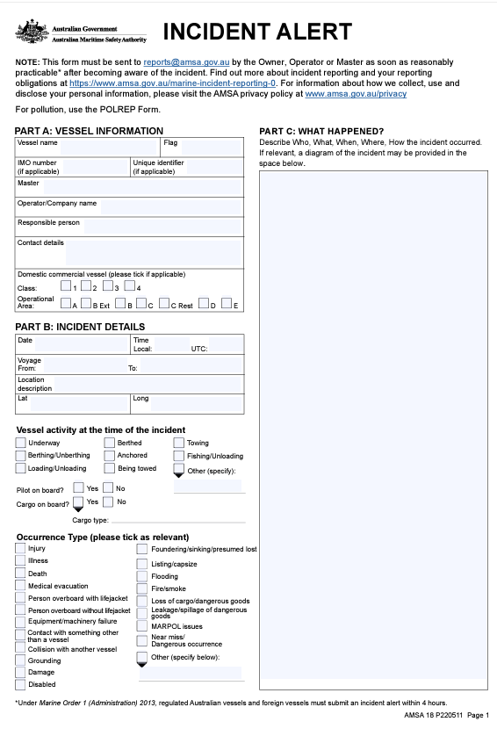

AMSA Form 18

AMSA Form 18

AMSA Form 18

Incident Report AMSA Form 19
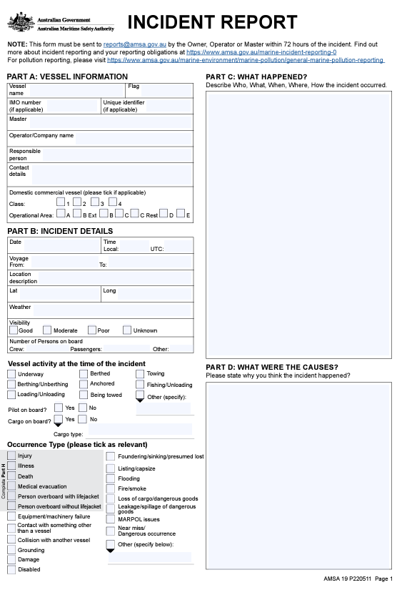

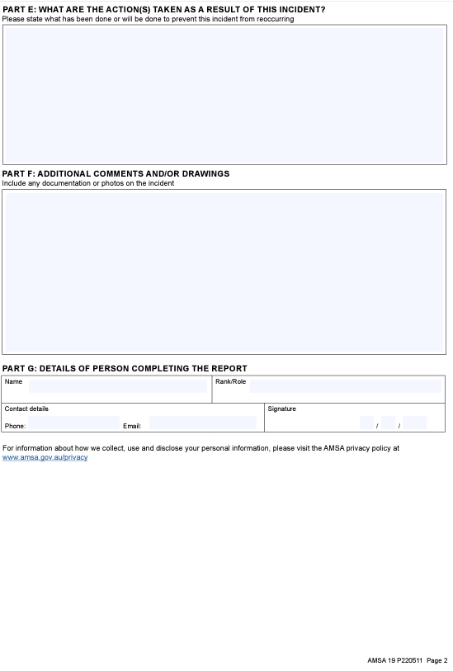
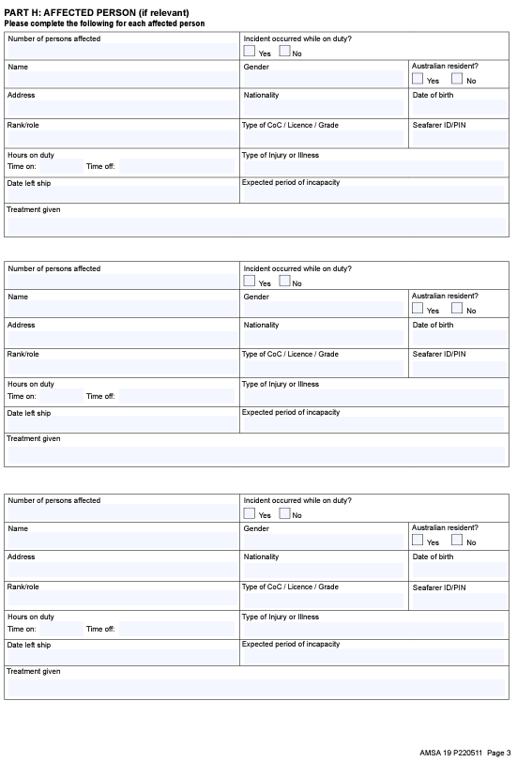

MAINTENANCE RECORD
VESSEL & EQUIPMENT MAINTENANCE RECORD
Date | Item Description | Maintenance Conducted | Conducted By | Signature
10/11/2023 | Full service | Fuel lines, engine fluids and parts, | Port drive marine

CREW MEMBER DETAILS
Master and Vessel Information
Company:
Master:
Vessel Name:
Vessel ID:
Crew Member Details
Name:
Position:
Contact Telephone Number:
Address:
Email Address:
Certificates Held:
Next of Kin
Name:
Contact Number:
Join / Depart Vessel
Date - Join Vessel | Date - Depart Vessel |  | Signature

CREW MEMBER DETAILS
Master and Vessel Information
Company:
Master:
Vessel Name:
Vessel ID:
Crew Member Details
Name:
Position:
Contact Telephone Number:
Address:
Email Address:
Certificates Held:
Next of Kin
Name:
Contact Number:
Join / Depart Vessel
Date - Join Vessel | Date - Depart Vessel |  | Signature

CREW MEMBER DETAILS
Master and Vessel Information
Company:
Master:
Vessel Name:
Vessel ID:
Crew Member Details
Name:
Position:
Contact Telephone Number:
Address:
Email Address:
Certificates Held:
Next of Kin
Name:
Contact Number:
Join / Depart Vessel
Date - Join Vessel | Date - Depart Vessel |  | Signature

CREW MEMBER DETAILS
Master and Vessel Information
Company:
Master:
Vessel Name:
Vessel ID:
Crew Member Details
Name:
Position:
Contact Telephone Number:
Address:
Email Address:
Certificates Held:
Next of Kin
Name:
Contact Number:
Join / Depart Vessel
Date - Join Vessel | Date - Depart Vessel |  | Signature

VESSEL LOG
LFB |  |  | MASTER:
LOG
Date | Time | Event | Comment
MASTER’S SIGNATURE:

VESSEL LOG
LFB |  |  | MASTER:
LOG
Date | Time | Event | Comment
MASTER’S SIGNATURE:

VESSEL LOG
LFB |  |  | MASTER:
LOG
Date | Time | Event | Comment
MASTER’S SIGNATURE:

VESSEL LOG
LFB |  |  | MASTER:
LOG
Date | Time | Event | Comment
MASTER’S SIGNATURE:

Skippers cards
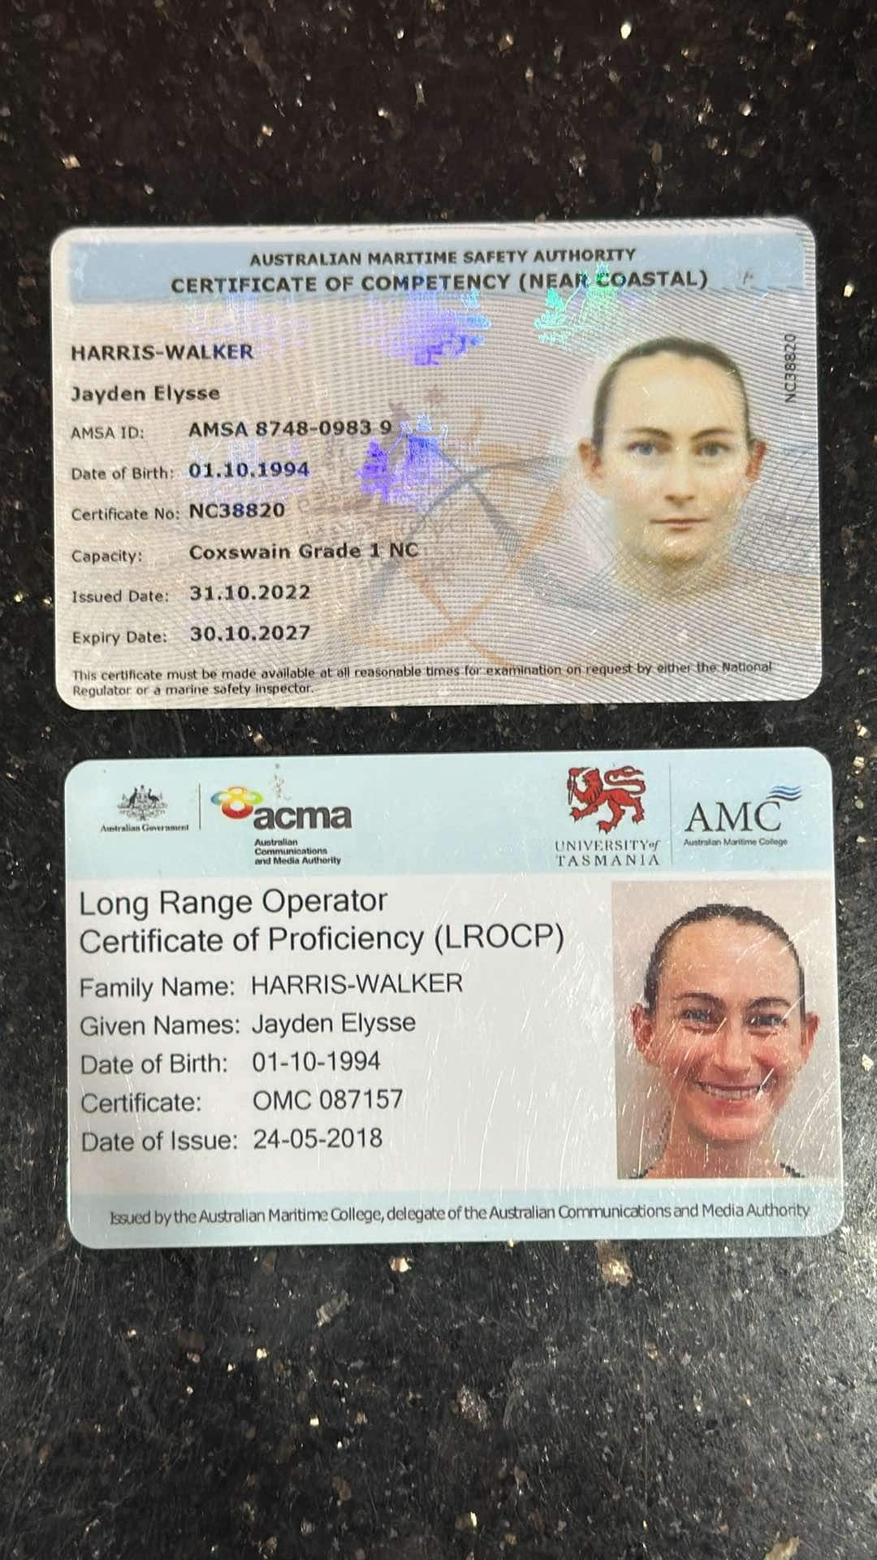
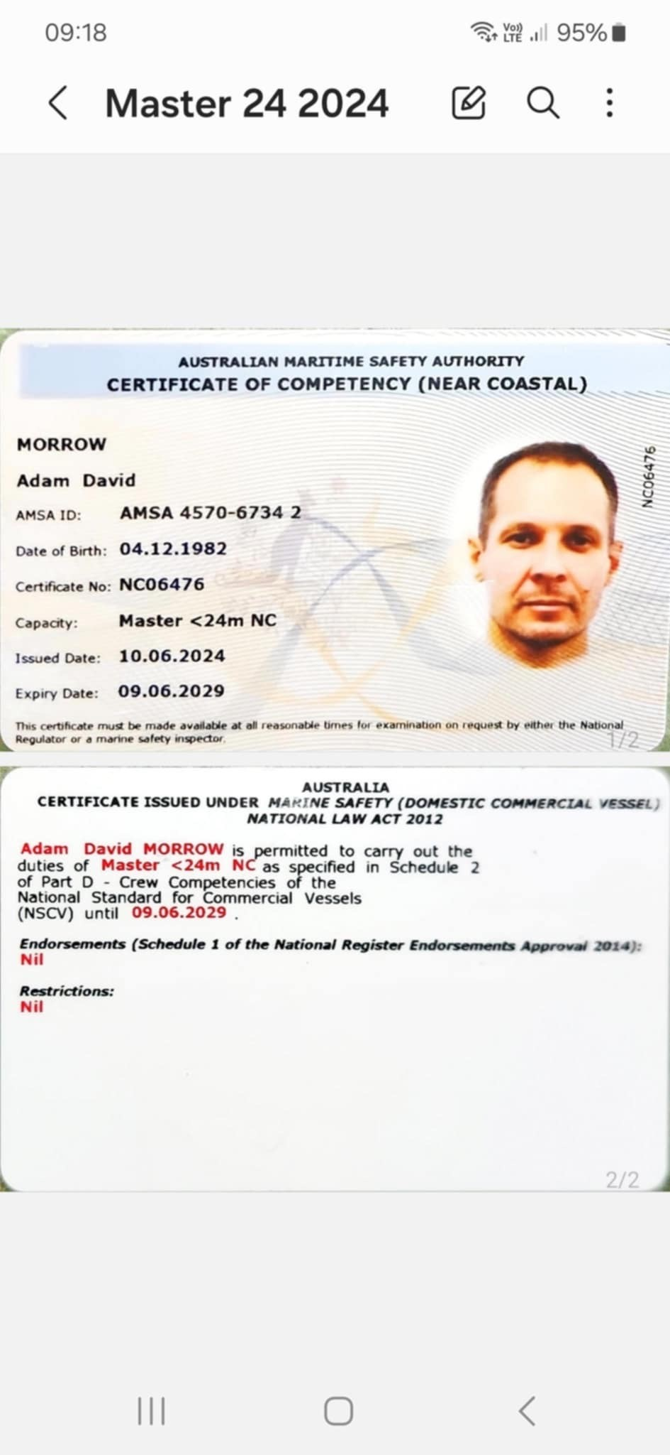

Australian 406 MHz Distress Beacon
Dear beacon owner,
The extract below confirms your beacon registration details, which we would like you to review.

Contact Details |  | Phone |  | Email
Graham MACKERETH  PO Box 5502  BROOME, WA, 6725 |  | (H) 0451113850  (W) 0451113850  (M) 0451113850 |  | laracs1@outlook.com
Emergency Contacts | Home Phone |  | Work Phone |  | Mobile Phone
Linda Mackereth |  |  |  |  | 0420393737

Registered | Beacon Hex ID/UIN | Serial Number | Beacon Model | Craft Name | Reg/Callsign | Reg. Expiry
15/09/2019 | 3EEC9A979EFFBFF | 1902524931 | MT406G GPS EPIRB | Gypsea | WA | 15/09/2021

Further information about distress beacons, updating your beacon registration details, adding trip details or uploading photos of your vessel, vehicle or aircraft is available at www.amsa.gov.au/beacons.
Thank you for your cooperation.
Australian 406 MHz Distress Beacon and MMSI Register
Vessel plate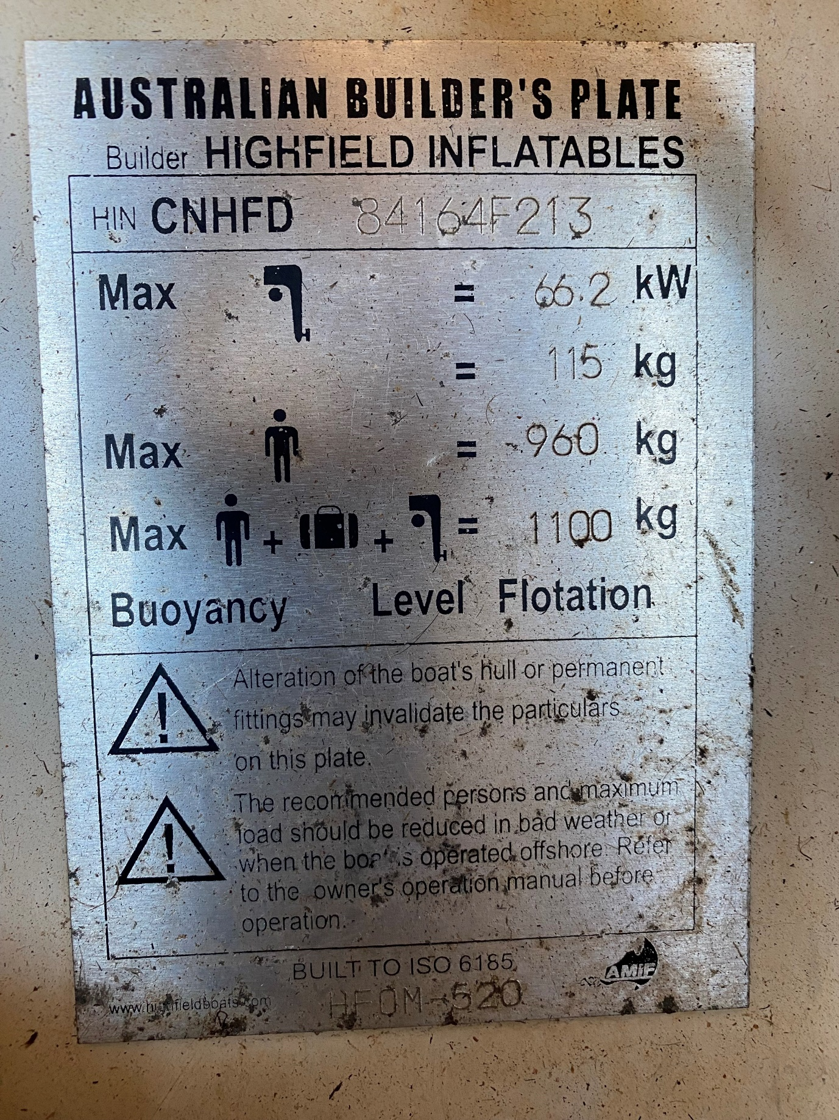

Engine plate
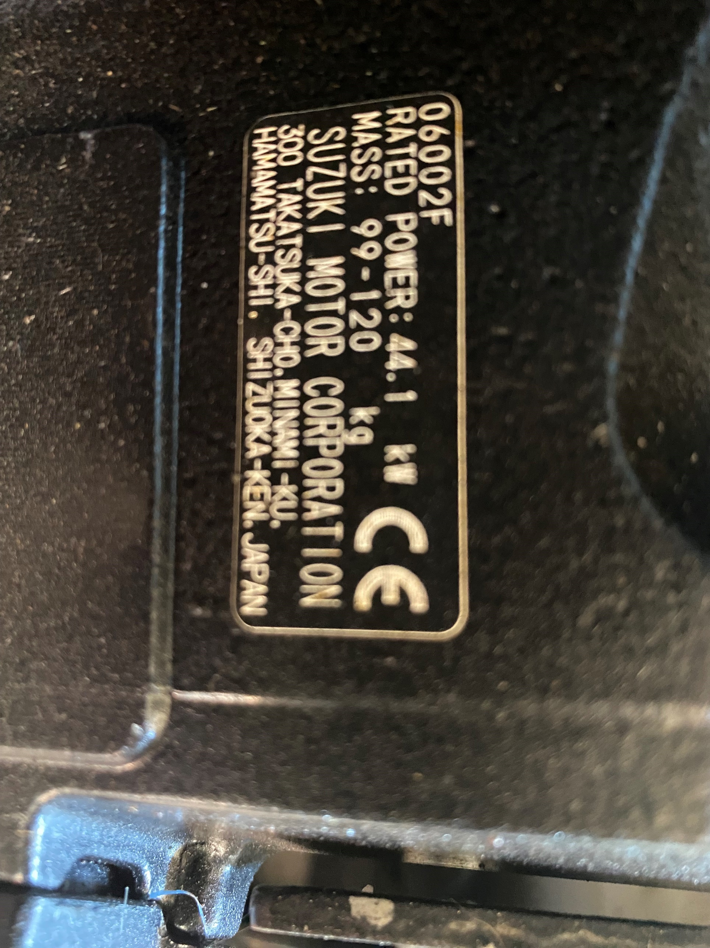

Last Service history
